**La imperial**

**Supervisor:** *NGUYỄN HẠ VY*

**Semester:** *01*

**Batch No:** *T3.2308.A0*

**Group No:** *04*

|  |  |  |
| --- | --- | --- |
| **Order** | **Full name** | **Roll No.** |
| *1.* | Nguyễn Chí Quyễn | Student1507659 |
| *2.* | Nguyễn Ngọc Hải | Student1507633 |
| *3.* | Huỳnh Tấn Lực | Student1507630 |
| *4.* | Nguyễn Minh Quân | student1508354 |

***Month****: 12* ***Year****: 2023*



This is to certify that

**Mr. NGUYỄN CHÍ QUYỄN Mr. NGUYỄN NGỌC HẢI Mr. HUỲNH TẤN LỰC**

**Mr. NGUYỄN MINH QUÂN**

Have successfully Designed & Developed

**La imperial**

Submitted by: **Mr. NGUYỄN CHÍ QUYỄN**

Date Of Issue:

22-12-2023

Authorized Signature:

**Mr. NGUYỄN CHÍ QUYỄN**

# Content

Content Acknowledge Synopsis

Review 1

Review 2

Review 3

Task sheet

# Acknowledge

As we understand that the eProject is a step-by-step learning environment that closely simulates the classroom and Lab-based learning environment into actual implementation. It is a project implementation at your fingertips! An electronic, live juncture on the machine that allows you to:

* Practice step by step i.e., laddered approach.
* Build a larger more robust application.
* Usage of certain utilities in applications designed by the user.
* Single program to unify code leading to a complete application.
* Learn implementation of concepts in a phased manner.
* Enhance skills and add value.
* Work on real-life projects.
* Give a real-life scenario and help to create applications that are more complicated and useful.
* Mentoring through email support.

First, I would like to thank India Aptech for allowing my team to work on this fantastic eProject. We had a great experience with eProject this time.

Next, we would like to express my special thanks to our mentor, Ms. Ha Vy for the time and effort that she provided throughout the project. Your helpful advice and suggestions were beneficial to us during the completion of the project. In this respect, we are forever grateful to you.

Besides several mistakes we made in the project, we hope to have more opportunities to widen our knowledge in the web-developing world.

We will try to continue to learn and improve ourselves even more in the future.

Yours Sincerely,

Team Group 6.

# Synopsis

The Objective of this program we aim is to give a sample project to work on real- life projects. These applications help us build a larger more robust application.

The objective is not to teach us HTML/JavaScript but to provide us with a real-life scenario and help us create basic applications using the tools.

Hence, we can revise the chapters before we start with the project.

This project is meant for students like us who have completed the module of HTML5. These programs should be done in the Lab sessions with the assistance of the faculty if required.

The website (in this project) is a tool that brings everything in the world to you such as historic monuments, information, natural knowledge and skills in technology...

It is essential for us to have a clear understanding of the subject. We think we should go through the project and solve the assignments as per the requirements given and get back [***eprojects@aptech.ac.in***](mailto:eprojects@aptech.ac.in) as the assigned schedule.

## Problem Definition

La Imperial is into selling Appliances. Company has been selling these products for the last 20 years. They have a wide range of Appliances. The company advertises by distributing the pamphlets, advertising on television and so on. Due to rapid development in the internet field, the company decided to launch a website where people will get all the information about the various products available with them easily.

The website is to be developed for the Windows Platform using HTML5, JavaScript,

ReactJS and Geolocation. The site should work well in all leading browsers including Chrome,

IE, Firefox etc.

**Requirement Specification:**

The Web site is to be created based on the following requirements.

1)Home Page should contain logo of the site with proper sections and details of Appliances with suitable images.

2)The site should display a menu which will contain the options for brief introduction about the various appliances available, location of the shop and any other information if required.

3)The information should be categorized according to the brand names of the products like if a User wants to see only “HAIER” products or any other companies products then he/she can click on a Link/button/menu etc and can see only that Brand products.

4)Another category option for different appliances, like ‘Washers & Dryers’ etc. should be created and accordingly the products should be listed.

5)When a user selects any particular brand, a list of products for that brand will be displayed

6)A brief summary of features of individual products should be displayed on the Web Page along with the product but detailed Features should be stored in Individual Word documents which can be downloaded or viewed by the User who wishes to see the same.

7)The user should also be able to compare the various products of different as well as similar brands.

8)There should be a “Contact Us” page which will have the Address of the Company which is as follows and the mail address which when clicked will invoke the local mail client from where they can send an email. Address of the Company should be displayed using GeoLocation API (eg. GoogleMaps).

## Customer Requirements Specifications

### User:

#### input:

* Information on search.
* Data of registered members.
* Feedback to the webmaster.
* purchase payment

#### Process:

* Find the searching
* Check the data of registered members.
* Check the feedback of users.
* Check user information

#### Output:

* Result of searching.
* Confirm the data of registered members.
* Confirm the feedback of the users.

-Confirm the user information

## Hardware/ software requirement:

#### Hardware:

* + A minimum computer system that will help you access all the tools in the courses is a Pentium 166 or better
  + 64 Megabytes of RAM or better

#### Software:

* + Notepad/HTML editor
  + MS IE / Chrome / Firefox / Netscape /MS Edge
  + React / Bootstrap
  + Dreamweaver / Figma

|  |  |
| --- | --- |
| **Document Name**:  Architecture and design of the project | **SWD/Form** No.03/ARD/Ver1.0 |
| **Version** 1.0 | **Page 3** |

**Architecture and design of the project**

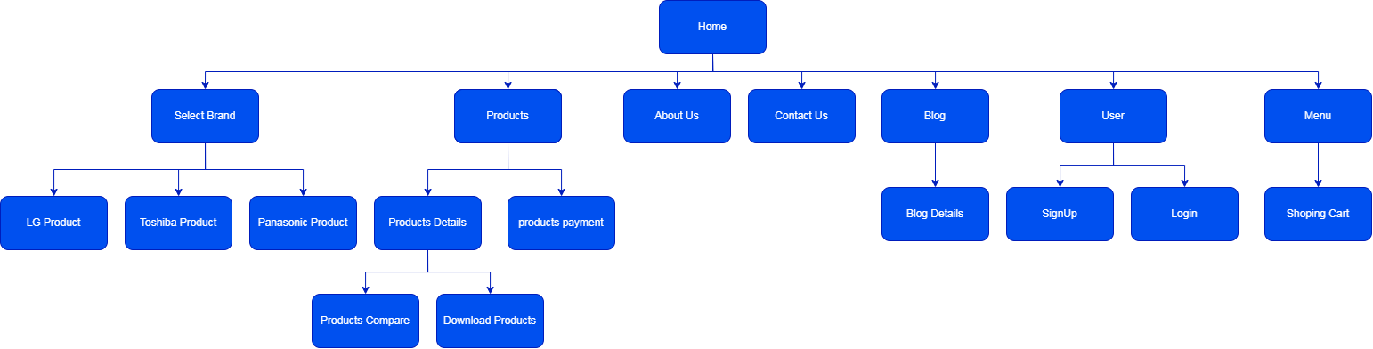

**TASK SHEET**

|  |  |  |  |  |  |  |  |
| --- | --- | --- | --- | --- | --- | --- | --- |
| No | Member | Contents | Page Name | Activity Plan | Date of Preparation of Activity Plan | | |
| Planed Start Date | Actual Start Date | Actual End Date | Status |
| 1 | Nguyễn Chí Quyễn | Homepage | homePage.js | 24/11/2023 | 25/11/2023 | 22/12/2023 | 100% |
| Nav-bar | NavBar.js | 24/11/2023 | 26/11/2023 | 22/12/2023 | 100% |
| Search | Search.js | 24/11/2023 | 27/11/2023 | 22/12/2023 | 100% |
| About Us | AboutUs.js | 24/11/2023 | 28/11/2023 | 22/12/2023 | 100% |
| Footer | Footer.js | 24/11/2023 | 29/11/2023 | 22/12/2023 | 100% |
| 2 | Nguyễn Ngọc Hải | Blog | Blog.js | 24/11/2023 | 30/11/2023 | 22/12/2023 | 0% |
| 3 | Huỳnh Tấn Lực | Products | ProductList.js | 24/11/2023 | 1/12/2023 | 22/12/2023 | 100% |
| Products Compare | CompareProductsPage.js | 24/11/2023 | 2/12/2023 | 22/12/2023 | 100% |
| Cart | CartLits.js | 24/11/2023 | 3/12/2023 | 22/12/2023 | 100% |
| Products Details | ProductDetails.js | 24/11/2023 | 4/12/2023 | 22/12/2023 | 100% |
| 4 | Nguyễn Minh Quân | Contact | Contact.js | 24/11/2023 | 5/12/2023 | 22/12/2023 | 100% |
| PayPage | Pay.js | 24/11/2023 | 6/12/2023 | 22/12/2023 | 100% |
| Blog | Blog.js | 24/11/2023 | 7/12/2023 | 22/12/2023 | 100% |
| Login | Login.js | 24/11/2023 | 8/12/2023 | 22/12/2023 | 100% |
| SignUp | Register.js | 24/11/2023 | 9/12/2023 | 22/12/2023 | 100% |

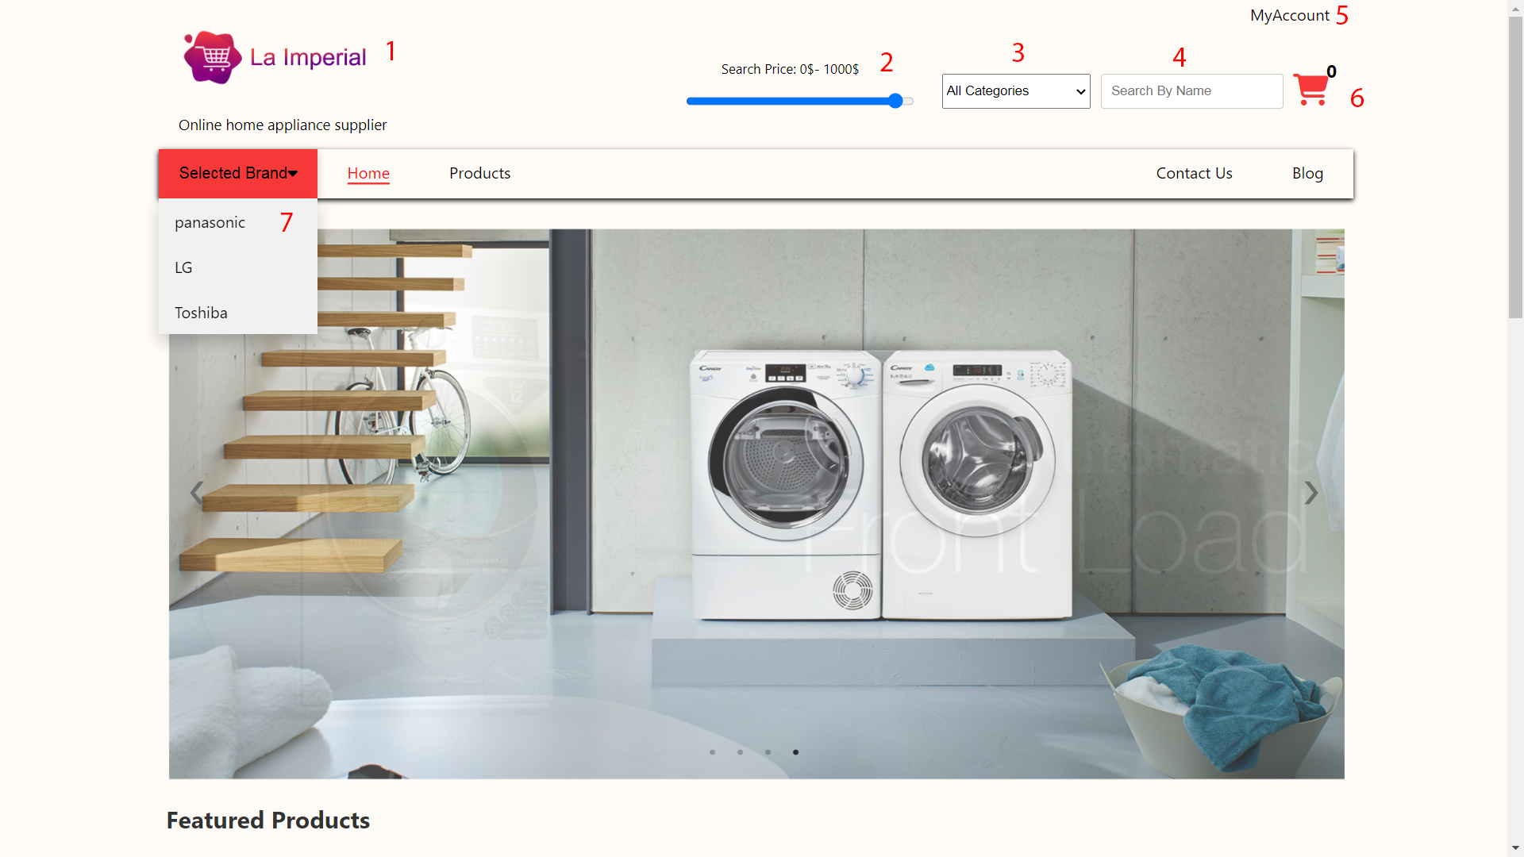

|  |  |  |  |  |
| --- | --- | --- | --- | --- |
| **No.** | **Type** | **Discription** | **Name** | **Note** |
| **1** | Click | When clicked, it redirects to the home page | home page navigation |  |
| **2** | Slippery | When dragging it will search for prices | Search price | The search section can search by many criteria |
| **3** | Click | when clicking on search option | Search select |
| **4** | Input | When entering characters, the search will be based on name | Search name |
| **5** | Click | When clicked, it will take you to the account page | Account page navigation |  |
| **6** | Click | Clicking will take you to the shopping cart page | Cart page navigation |
| **7** | Click | Clicking will take you to the shopping brand page | Brand page navigation |

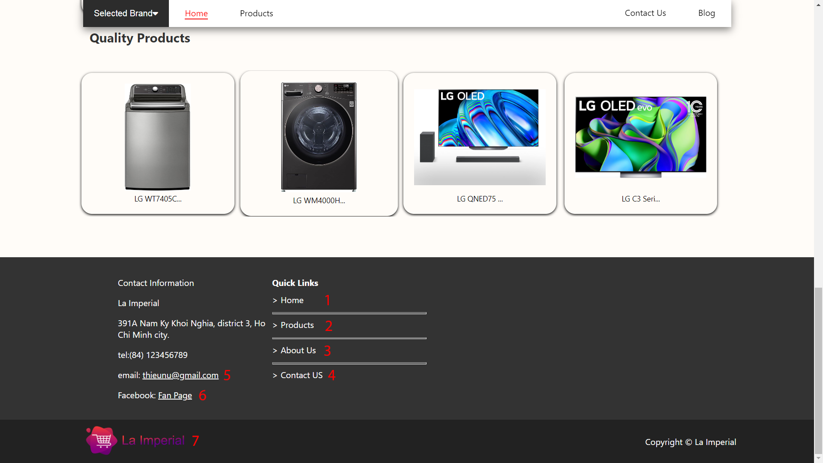

|  |  |  |  |
| --- | --- | --- | --- |
| **No.** | **Type** | **Discription** | **Name** |
| **1** | Click | When clicked, it redirects to the home page | home page navigation |
| **2** | Click | Clicking will take you to the products page | Products page navigation |
| **3** | Click | Clicking will take you to the about us page | About us page navigation |
| **4** | Click | Clicking will take you to the contact us page | Contact us page navigation |
| **5** | Click | Clicking will take you to the mail | Mail |
| **6** | Click | Clicking will take you to the facebook | Facebook navigate |
| **7** | Click | When clicked, it redirects to the home page | home page navigation |

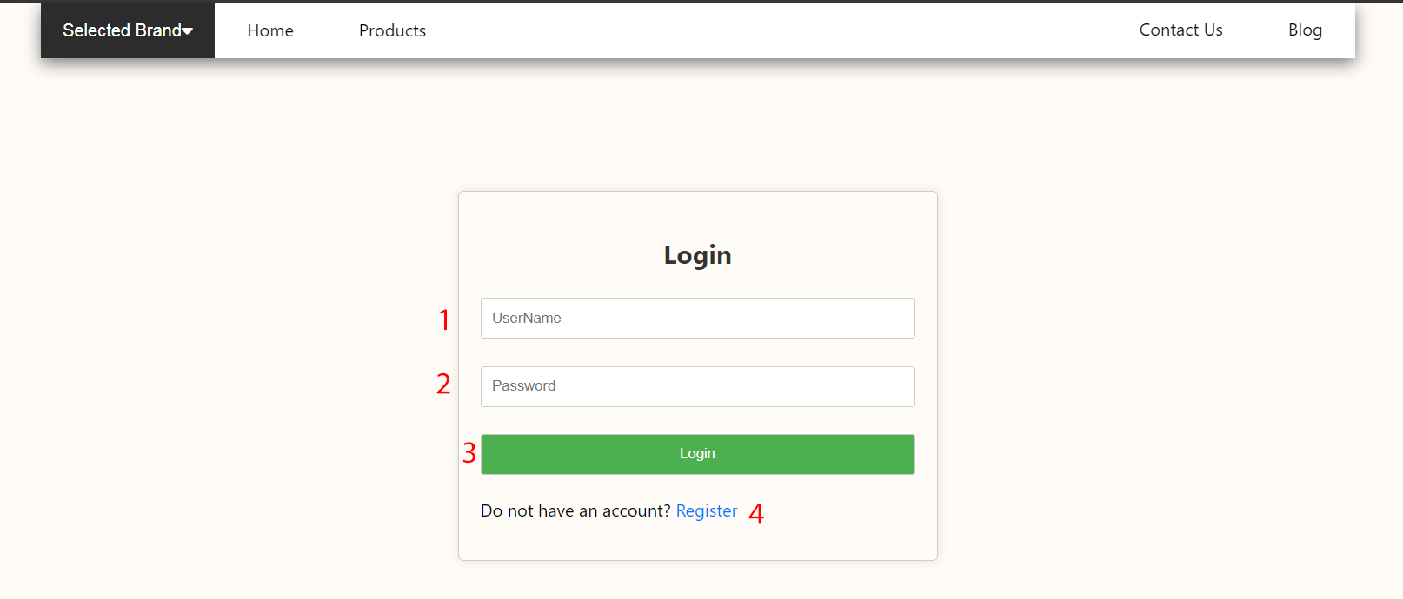

|  |  |  |  |  |
| --- | --- | --- | --- | --- |
| **No.** | **Type** | **Discription** | **Name** | **Validation** |
| **1** | Input | Once you enter the correct account, you will be logged in and can make purchases | User name | Required name |
| **2** | Input | Password | Required password |
| **3** | Button | Submit | Required name,password |
| **4** | Click | when pressed redirects to the registration page | Register page |  |

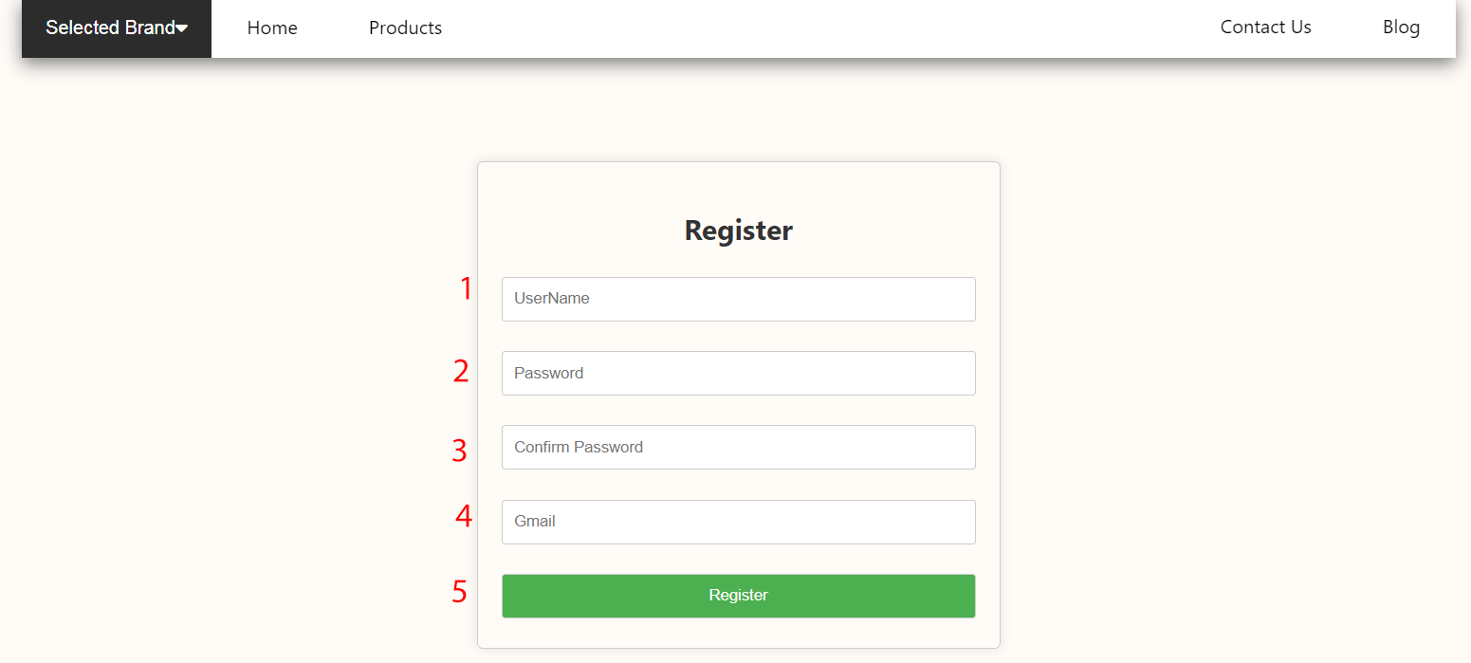

|  |  |  |  |  |
| --- | --- | --- | --- | --- |
| **No.** | **Type** | **Discription** | **Name** | **Validation** |
| **1** | Input | When you click, you will register an account and log in | User name | Required name |
| **2** | Input | Password | Required password |
| **3** | Input | Comfirm password | Required comfirm password |
| **4** | Input | Gmail | Required Gmail |
| **5** | Button | When you click, your account registration is successful and you move to the login page | Submit account | Required  input all register |
|  |  |  |  |  |

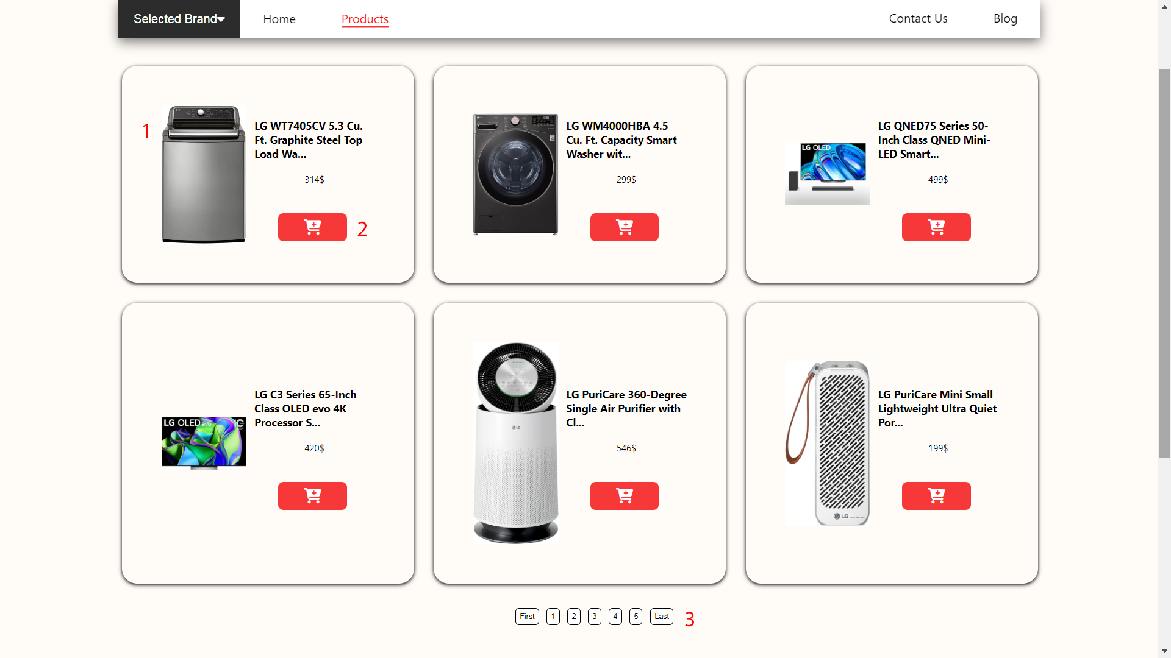

|  |  |  |  |
| --- | --- | --- | --- |
| **No.** | **Type** | **Discription** | **Name** |
| **1** | Click | When clicked, it redirects to the Products details page | Products details page navigation |
| **2** | Click | When clicked, the product will be added to the cart | Add cart |
| **3** | Click | When clicked, it will move to the next page and vice versa | pagination |

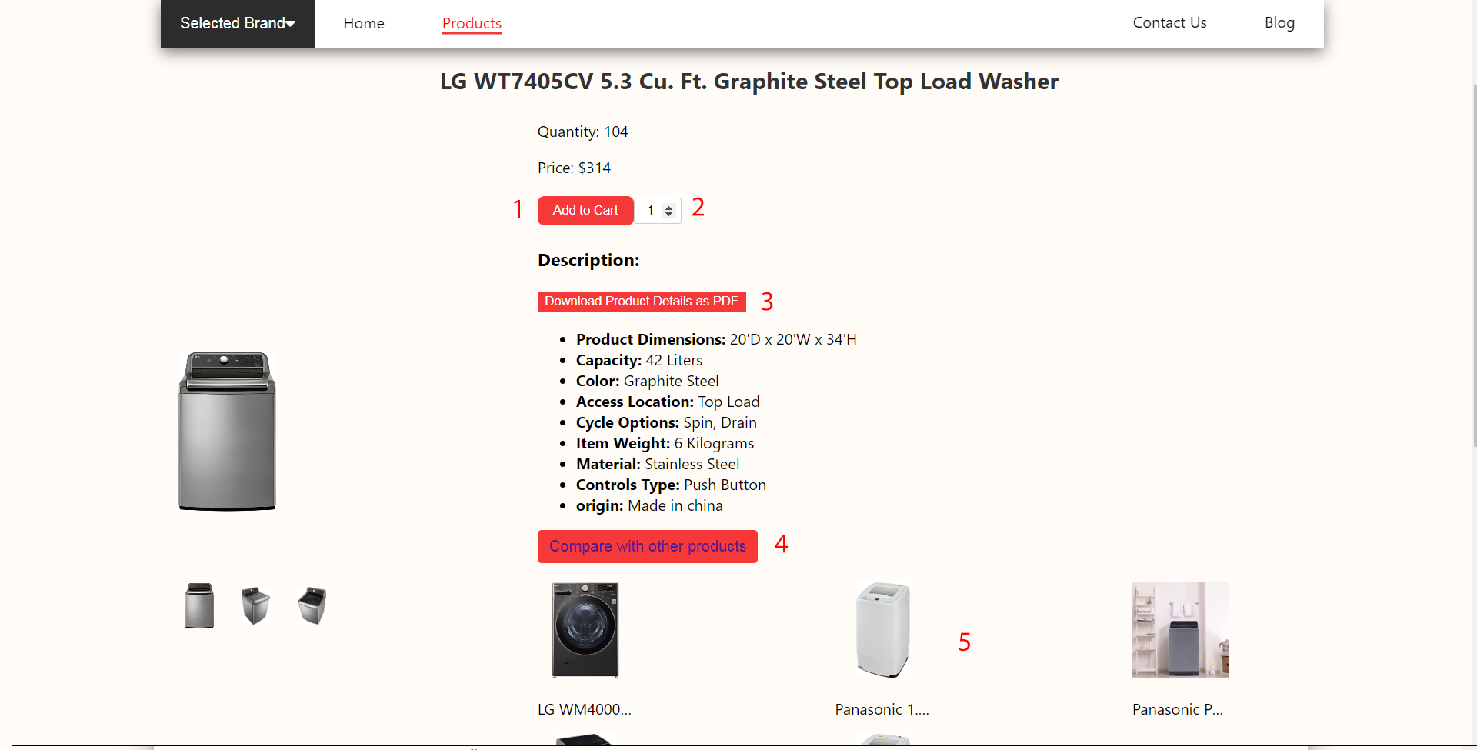

|  |  |  |  |
| --- | --- | --- | --- |
| **No.** | **Type** | **Discription** | **Name** |
| **1** | Click | When clicked, the product will be added to the cart | Add cart |
| **2** | Click | When you click, you will add more or less products to buy and click add to cart | Add products by quantity |
| **3** | Click | Clicking will download a pdf file with product details | Dowload file pdf products details |
| **4** | Click | When you click on a product you will be able to compare similar products and compare the first product | Compare products |
| **5** | Click | When you click on it, you will compare it with that product | Compare products |

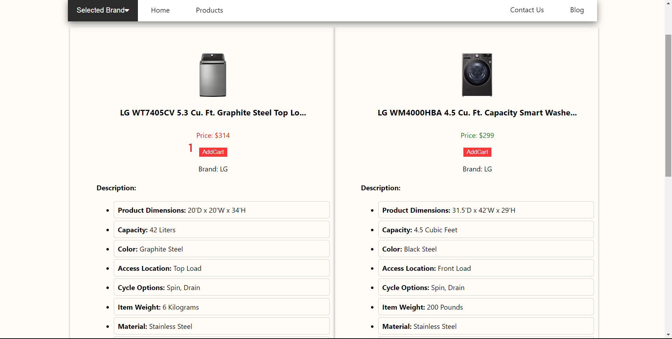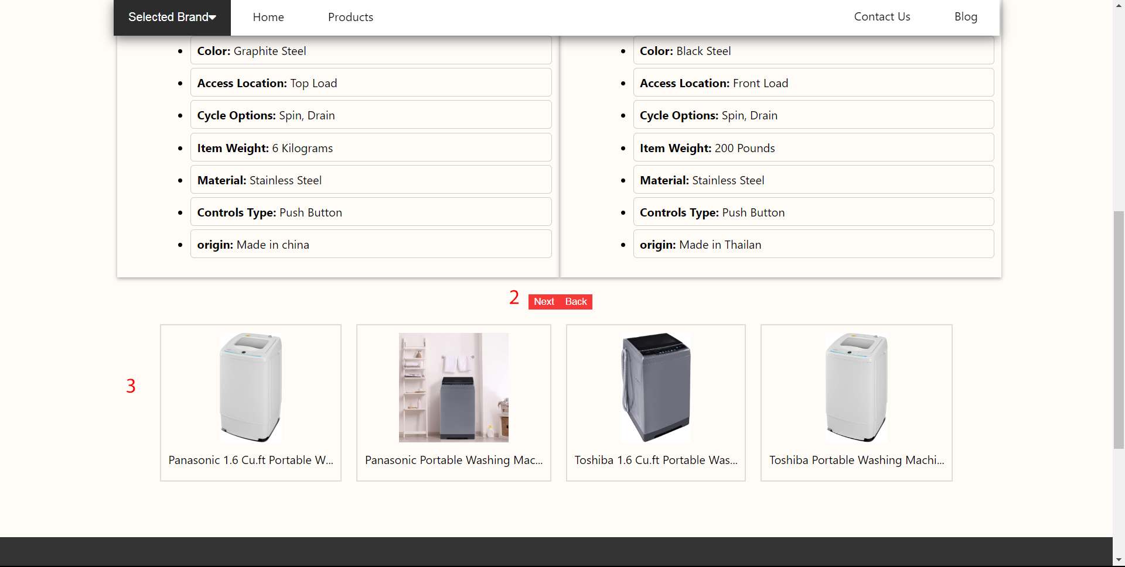

|  |  |  |  |
| --- | --- | --- | --- |
| **No.** | **Type** | **Discription** | **Name** |
| **1** | Click | When clicked, the product will be added to the cart | Add cart |
| **2** | Click | When you click next, the next product will be compared and vice versa | Next and back product |
| **3** | Click | When you click on a product you will be able to compare similar products and compare the first product | Compare products |

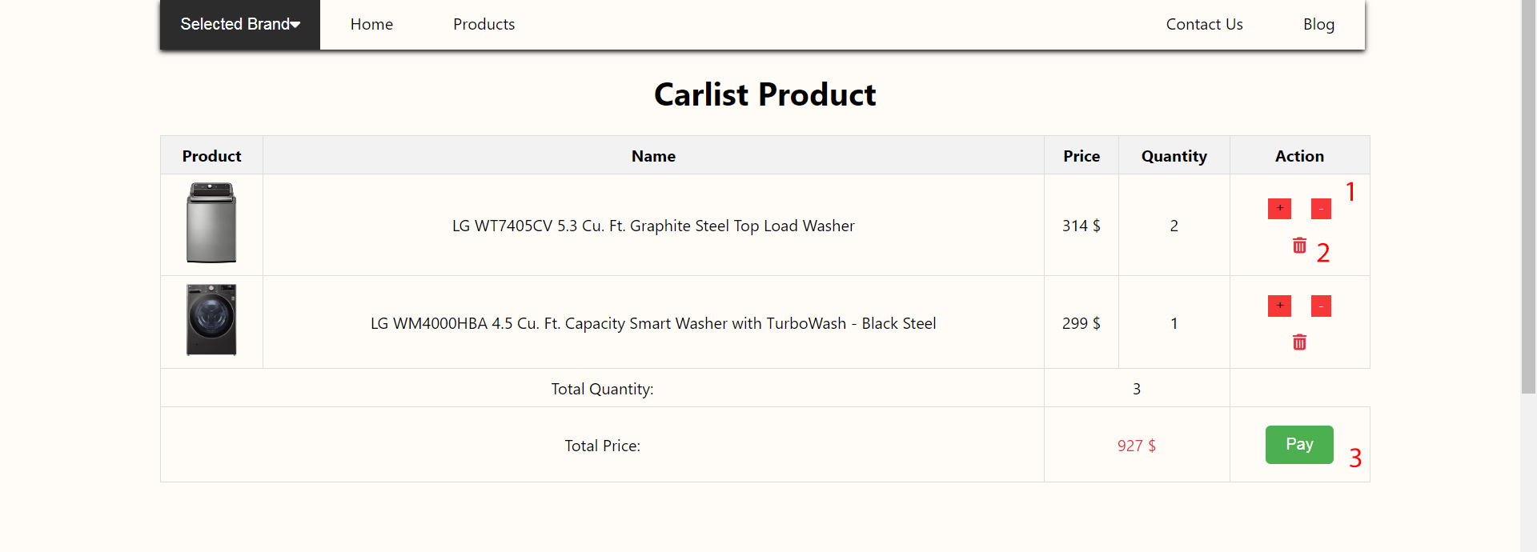

|  |  |  |  |
| --- | --- | --- | --- |
| **No.** | **Type** | **Discription** | **Name** |
| **1** | Click | Increase or decrease the number of products in the shopping cart | Number of products in the cart |
| **2** | Click | When you click on the product, it will be completely deleted | Delete cart products |
| **3** | Click | When you click, you will go to the product payment page | Buy product |

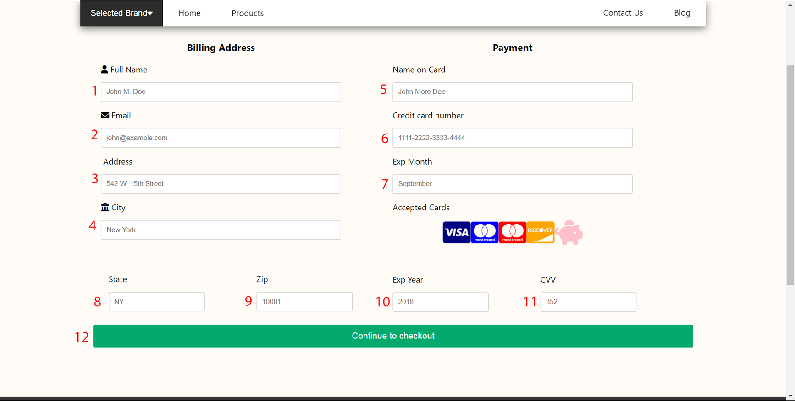

|  |  |  |  |  |
| --- | --- | --- | --- | --- |
| **No.** | **Type** | **Discription** | **Name** | **Validation** |
| **1** | Input | Information needed for payment | Full name | Required Full name |
| **2** | Input | Email | Required Email |
| **3** | Input | Address | Required Address |
| **4** | Input | City | Required City |
| **5** | Input | Name on cart | Required Name on cart |
| **6** | Input | Credit cart number | Credit cart number |
| **7** | Input | Exp Month | Required Exp Month |
| **8** | Input | State | Required State |
| **9** | Input | Zip | Required Zip |
| **10** | Input | Exp Year | Required Exp Year |
| **11** | Input | CVV | Required CVV |
| **12** | Button | Upon checkout, it will redirect to the product page | Submit payment | Required input all pay page |

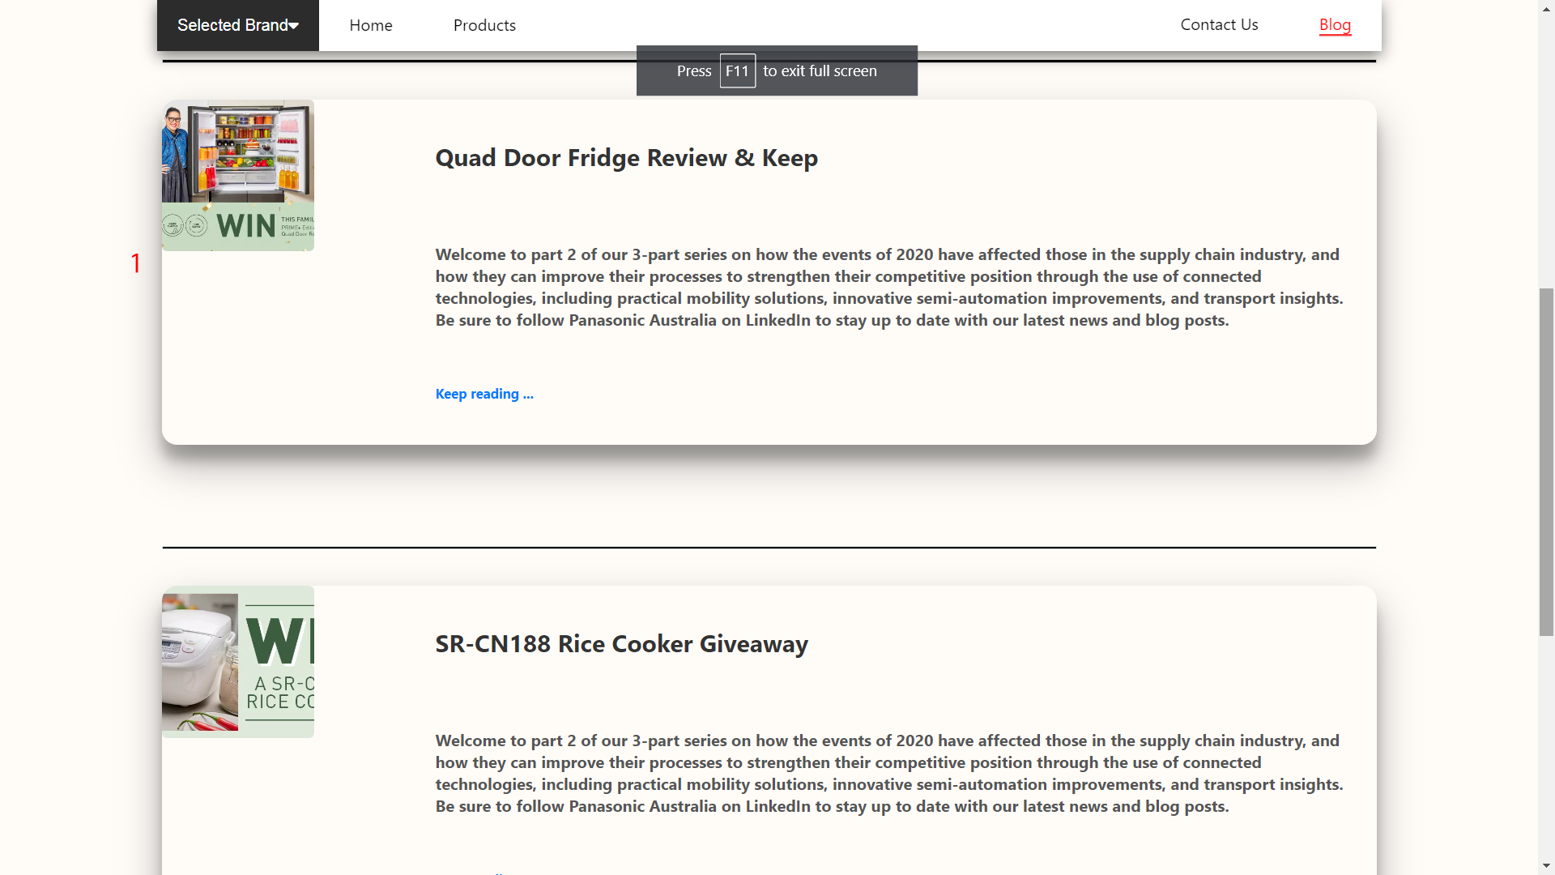

|  |  |  |  |
| --- | --- | --- | --- |
| **No.** | **Type** | **Discription** | **Name** |
| **1** | Click | When clicked, it will go to the Blog details page | Blog navigate |

*Note: that we have made the Iphone 14 pro max device responsive*

